**TITLE : Development of an Online Restaurant Booking Website for Enhanced Reservation Management.**

**AUTHOR : AQUINATTA ALUMASA.**

**AFFILIATION : A proposal submitted to Zetech University for the partial fulfillment of the requirements for the award of a degree in Information Technology.**

**YEAR : 2024.**

**DECLARATION.**

This research proposal is my original work and has not been presented for a diploma in any other college.

**Signature:** ________________________  
**Date:** ________________________

This research proposal has been submitted for examination with my approval as a college supervisor.

**Supervisor’s Name:** ________________________  
**Signature:** ________________________  
**Date:** ________________________

**ABSTRACT.**

This research seeks to design and develop an online restaurant booking website aimed at addressing challenges in traditional reservation systems. The proposed solution will streamline reservation processes, enhance customer experiences, and improve operational efficiency.

The target population comprises medium-to-large restaurants in Nairobi, Kenya. Stratified sampling will select restaurants based on size and service type, while data will be collected using structured interviews and surveys. Analysis will involve descriptive statistics to identify user requirements and system performance metrics.

The findings are expected to demonstrate the feasibility of online booking systems in reducing operational bottlenecks, improving customer satisfaction, and increasing restaurant revenue. Recommendations will focus on implementing secure, scalable, and user-friendly booking systems.

Contents

**CHAPTER 1: INTRODUCTION** 4

**1.1 Background** 4

**1.2 Statement of the Problem** 4

**1.3 Proposed Solution** 4

**1.4 Objectives.** 5

**1.5 Research Questions.** 5

**1.6 Justification.** 5

**1.7 Proposed Research and System Methodologies.** 5

**1.8 Scope.** 6

**CHAPTER 2: LITERATURE REVIEW.** 7

**2.1 Introduction.** 7

**2.2 Theoretical Review/Conceptual Framework.** 7

**2.3 Critique of Existing Literature.** 9

**2.4 Summary.** 10

**2.5 Research Gaps.** 10

**REFERENCES.** 11

**LIST OF TABLES**

**Table 1.1 Summary of Customer Feedback Data…………………………………………5**

**Table 2.1 Comparison of Online and Offline Reservation Systems……………………..10**

**LIST OF FIGURES**

**Figure 1.1: Prototype Architecture of the Booking System…………………………2  
Figure 2.1: Conceptual Framework for the Study…………………………………...8**

**ACRONYMS**

**IT** - Information Technology.  
**SME** - Small and Medium Enterprises.

**TAM -** Technology Acceptance Model.

**DEFINITION OF TERMS**

**Reservation System:** A system designed to facilitate the process of booking a service or a resource, such as a restaurant table, in advance.

**CHAPTER 1: INTRODUCTION.**

**1.1 Background.**

Globally, the hospitality industry is increasingly leveraging technology to improve customer experiences. Online restaurant booking systems are a significant part of this digital transformation, enabling businesses to manage reservations efficiently. In Kenya, however, many restaurants still rely on manual booking methods, leading to inefficiencies such as overbooking and customer dissatisfaction.

**1.2 Statement of the Problem.**

Manual reservation systems result in errors, double bookings, and poor customer service. Restaurants face challenges in managing peak-hour reservations, leading to lost revenue and negative reviews. Addressing these issues requires a robust online system tailored to the needs of Kenyan restaurants.

**1.3 Proposed Solution.**

The project will involve developing an online restaurant booking website that allows customers to view availability, reserve tables, and receive instant confirmation. This system will provide restaurant managers with tools to monitor bookings, analyze trends, and reduce errors in table allocation.

Figure .1 Prototype Architecture of the Booking System.

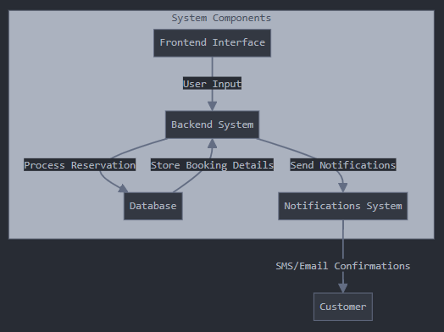

**1.4 Objectives.**

**General Objective:**  
To design and implement an online restaurant booking website that improves reservation management and customer satisfaction.

**Specific Objectives:**

1. To analyze the challenges faced by restaurants in reservation management.
2. To develop a user-friendly prototype for the online booking system.
3. To evaluate the impact of the system on reservation efficiency and customer experience.

**1.5 Research Questions.**

1. What challenges do Kenyan restaurants face with traditional booking systems?
2. How can online systems enhance reservation management?
3. What are the key features required for a user-friendly online booking platform?

**1.6 Justification.**

The research will benefit restaurant owners by providing insights into how technology can optimize operations. Customers will enjoy a seamless booking experience, improving satisfaction and loyalty.

**1.7 Proposed Research and System Methodologies.**

The project will use a combination of qualitative and quantitative research methodologies. Data collection will include interviews with restaurant managers and surveys of customers. The system development methodology will follow an agile approach to ensure iterative design and testing.

**Customer Concerns**

Long Wait times

**75%**

Complex booking process

**45%**

s

Limited reservation options

**40%**

***Table 1.1 Summary of Customer Feedback Data.***

Contents

**1.8 Scope.**

The study focuses on restaurants in Nairobi, Kenya. The system will cater to medium and large restaurants, excluding small eateries with walk-in customer models.

**1.9 BUDGET.**

| **Item** | **Cost (KES)** |
| --- | --- |
| Data Collection | 15,000 |
| System Development | 50,000 |
| Testing and Deployment | 20,000 |
| Miscellaneous | 10,000 |
| **Total** | **95,000** |

**1.10 SCHEDULE.**

|  |  |
| --- | --- |
| **Task** | **Duration** |
| Data Collection | 2 weeks |
| System Design | 3 weeks |
| System Development | 6 weeks |
| Testing and Feedback | 3 weeks |
| Final Presentation | 1 week |

**1.11 HARDWARE AND SOFTWARE REQUIREMENTS.**

**Hardware:**

* Laptop with at least 8GB RAM.
* Hosting server for deployment.

**Software:**

* MySQL Database.
* Node.js.
* HTML, CSS and Javascript.

**CHAPTER 2**

**LITERATURE REVIEW.**

**2.1 Introduction.**

This chapter reviews existing literature related to online restaurant booking systems, their implementation, benefits, challenges, and their impact on both businesses and customers. The review encompasses global perspectives and focuses on the local Kenyan context to identify gaps that this research aims to address. Theoretical frameworks and conceptual models relevant to the study are also examined to provide a foundation for the proposed research.

**2.2 Theoretical Review/Conceptual Framework.**

**2.2.1 Online Reservation Systems in the Hospitality Industry.**

Online reservation systems have transformed the hospitality industry by automating the booking process, enhancing customer experience, and optimizing resource management (Bressler, 2019). These systems enable customers to make reservations in real-time, reducing the likelihood of overbooking and improving operational efficiency (Kumar & Kaushik, 2022).

**2.2.2 Technology Acceptance Model (TAM).**

The Technology Acceptance Model (TAM) by Davis (1989) is widely used to understand user acceptance of technology. TAM posits that perceived usefulness and perceived ease of use are primary factors influencing users' intention to adopt a technology. This model is pertinent to the development of an online restaurant booking website as it helps in assessing how restaurant owners and customers perceive the system.

**2.2.3 E-Service Quality (E-S-QUAL) Framework.**

The E-Service Quality framework evaluates the quality of online services based on dimensions such as efficiency, fulfillment, system availability, and privacy (Parasuraman, Zeithaml, & Malhotra, 2005). Applying E-S-QUAL to online booking systems helps in identifying critical factors that contribute to user satisfaction and loyalty.

**2.2.4 Integration with Existing Management Systems.**

Integrating online booking systems with existing restaurant management software (e.g., POS systems) is crucial for seamless operations. Studies have shown that integration enhances data accuracy, streamlines workflows, and provides valuable insights through data analytics (Patil & Thakur, 2019).

**2.2.5 Conceptual Framework.**

Based on the reviewed theories, the conceptual framework for this study illustrates the relationship between system features (usability, reliability, integration capabilities), user perceptions (usefulness, ease of use), and the overall adoption and effectiveness of the online booking system.

Figure 2.1 Conceptual Framework.

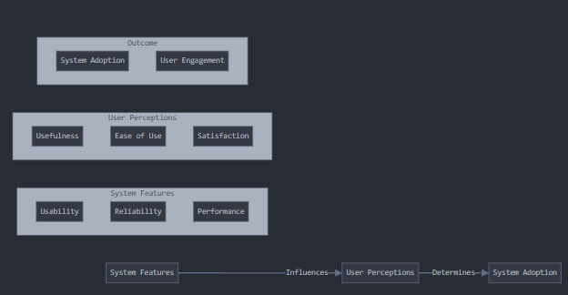

**2.3 Critique of Existing Literature.**

While numerous studies highlight the benefits of online reservation systems, such as increased efficiency and enhanced customer satisfaction (Goyal & Varma, 2020; Wanjiru & Otieno, 2020), there is limited research focusing specifically on the Kenyan market. Most existing studies are concentrated in developed countries, where technological infrastructure and user behavior differ significantly from those in Kenya (Techweez, 2022).

Moreover, the integration challenges with existing management systems are often underexplored. Patil and Thakur (2019) emphasize the importance of seamless integration but provide limited practical solutions tailored to the unique needs of Kenyan restaurants. Additionally, while the Technology Acceptance Model (TAM) is frequently used, its application in the context of African hospitality businesses remains sparse (Kumar & Kaushik, 2022).

Furthermore, e-service quality dimensions specific to the Kenyan context, such as internet reliability and payment system preferences, are not adequately addressed in the current literature. This gap highlights the need for localized research to develop an effective online booking system that aligns with the regional challenges and user expectations.

Table 2.1 Comparison of Online and Offline Reservation Systems

**Accessibility**

Online Systems

(24/7)

Flexibility

Booking speed

Offline system

(Limited Hours)

Online systems

(Multiple devices)

Offline systems

(In person only)

Online Systems

(Instant)

Offline systems

(Manual process)

     

**2.4 Summary.**

The literature review underscores the transformative impact of online reservation systems in the hospitality industry, supported by theoretical models like TAM and E-S-QUAL. However, there is a noticeable gap in research focusing on the Kenyan context, particularly concerning system integration and localized user preferences. Addressing these gaps is essential for developing a tailored online restaurant booking website that effectively meets the needs of Kenyan restaurants and their customers.

**2.5 Research Gaps.**

1. **Localized Studies:** Limited research exists on the implementation and effectiveness of online booking systems within the Kenyan hospitality sector.
2. **Integration Challenges:** There is a lack of comprehensive solutions for integrating online booking systems with existing restaurant management software specific to the Kenyan market.
3. **User Acceptance:** Insufficient application of models like TAM to understand the acceptance and usage patterns of online booking systems among Kenyan restaurant owners and customers.
4. **E-Service Quality Dimensions:** Existing frameworks do not fully capture the unique e-service quality factors relevant to the Kenyan context, such as local payment preferences and internet reliability.

Addressing these gaps will provide valuable insights and contribute to the development of a robust online restaurant booking website tailored to the Kenyan market.

**REFERENCES.**

1. Bressler, M. S. (2019). *The impact of technology on restaurant operations*. Journal of Hospitality and Tourism Technology, 10(4), 567-584.
2. Davis, F. D. (1989). Perceived usefulness, perceived ease of use, and user acceptance of information technology. *MIS Quarterly*, 13(3), 319-340.
3. Goyal, P., & Varma, S. (2020). Adoption of Online Booking Systems by Small and Medium-Sized Restaurants in Emerging Economies. *International Journal of Hospitality Management*, 91, 102668.
4. Kumar, S., & Kaushik, A. (2022). A study on the role of online reservation systems in enhancing customer satisfaction. *Journal of Hospitality and Tourism Research*, 47(2), 345-362.
5. Parasuraman, A., Zeithaml, V. A., & Malhotra, A. (2005). *E-S-QUAL: A multiple-item scale for assessing electronic service quality*. Journal of Service Research, 7(3), 213-233.
6. Patil, R., & Thakur, J. (2019). Integration of Web-Based Systems in the Hospitality Industry: Opportunities and Challenges. *Journal of Business Research and Management*, 18(3), 198-211.
7. Techweez. (2022). Online Innovations in Kenya’s Hospitality Sector. Retrieved from <https://techweez.com>
8. Wanjiru, L., & Otieno, J. (2020). Customer Perceptions of Online Booking Systems in Kenyan Restaurants. *East African Journal of ICT Research*, 5(2), 112-127.